AI-AGV Warehousing Solutions:
The Future of e-Commerce & Retail

Liftians Inc., a California company

Date: January 25, 2018
Version: 2.0

Do not reprint
All Rights Reserved
Liftians Inc. 2018

Section 1 – An Introduction to Our MHS

Our MHS system improves efficiency, reduces costs, eliminates error rates, eases the workload of workers, and streamlines any existing warehouse system data (from SPD/WMS/ERP systems, etc.).
Automated guided vehicle units (AGVs) automatically navigate throughout your warehouse, transporting the designated shelves to a pick-up station. Workers do not need to be on the warehouse floor. We use QR-code technology to coordinate AGV movement. All products, shelves, locations, and AGV units have unique IDs, which avoids the problem of manual identification and takes human error out of the equation.
The core of our software includes data collection and artificial intelligence algorithms, which optimizes transportation tasks and paths in real-time.
Liftians’ MHS system installs in 3 months—it is a fast and accurate intelligent warehousing and logistics management system. We currently have an approximate 2:1 labor ratio—one AGV unit performs the tasks of two workers.

Section 2 – System Product Specifications

(1) Software System primary functionalities:
- Seamless integration with existing systems such as SPD/WMS/WCS
- On-demand replenishment & regular replenishment
- Picking and Return AGV operations
- Full and dynamic inventory tracking
- Projected optimal shelf positioning
- Inventory management (inventory reserve control, FIFO operating principle, etc.)
- Real-time monitoring of unit and shelf position and status
- AGV path optimization
- Predictive analytics system
- Automatic AGV docking and charging

(2) AGV Unit parameters:
- Maximum Speed: 1.5 m/s
- Maximum Load: 400 kg
- Battery Life: 5-7 hours
- Full Charge: 1 hour
- Battery Charges: >2000
- Collision Sensor: frontal laser

(3) Smart Operator Station features:
- Can process and fulfill 10 customer box orders (or can be customized according to client needs)
- Worker-interface picking application (item barcode scanning)
- Can connect with client-side conveyer belt, if necessary

(4) Shelf parameters:
- Customizable (a) number of layers and (b) number of cells per layer
- Single-layer maximum load: 100 kg
- Adjustable height
- Shock-absorbent chassis design

Section 3 – System Overview

(1) Liftians System Operational Parameters:
Parameter 1: Each workstation picks at least at 200 SKUs/hour,
Parameter 2: approximately 6 AGVs service a workstation,
Parameter 3: maximum 1:3 ratio of charging to working AGVs,

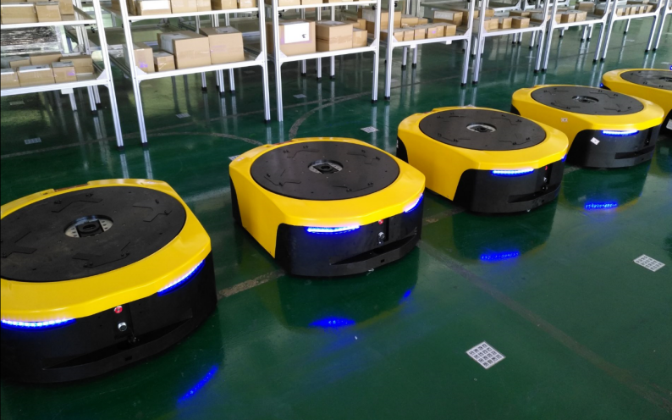
FIG 1: AGVs, shelves, and items. QR-code applied as stickers on warehouse floor.

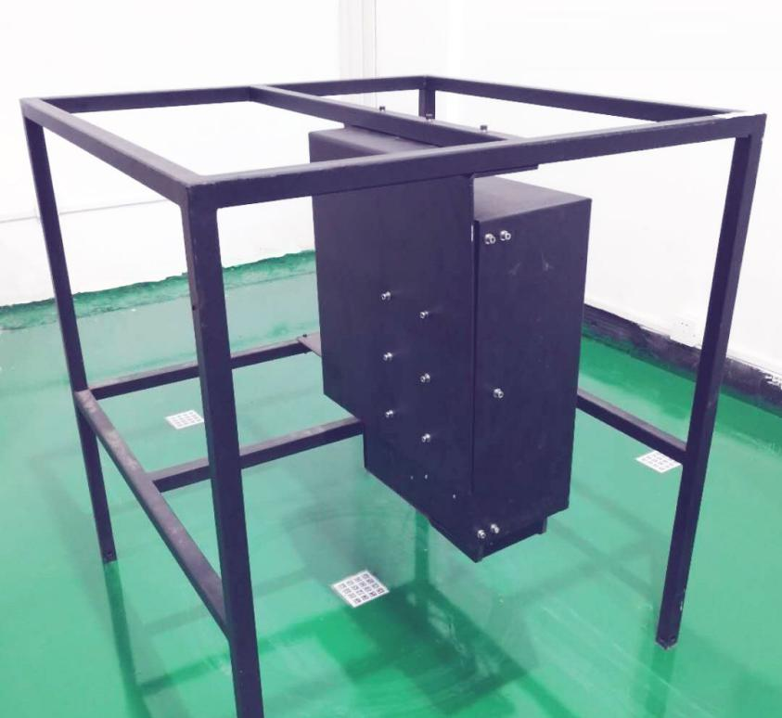
FIG 2: A charging station.
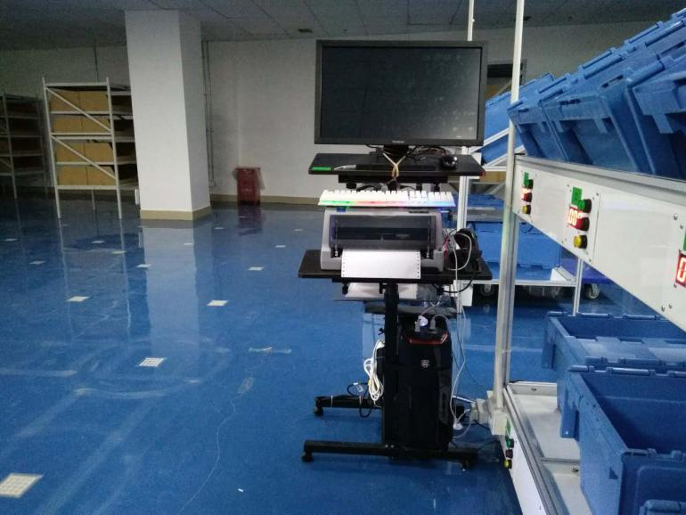
FIG 3: Worker-interface picking station.

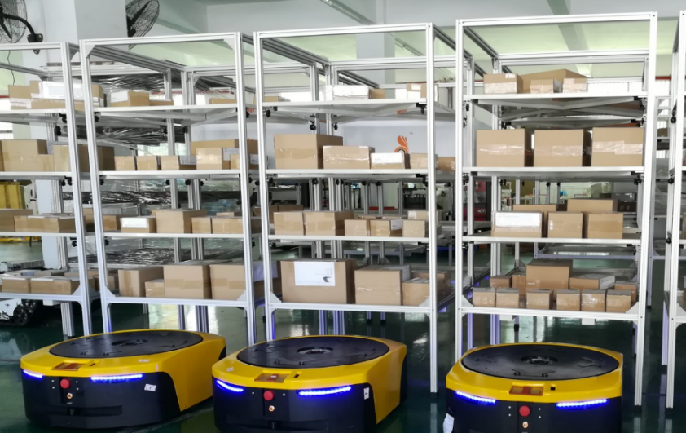
FIG 4: Standard shelves - about 393 cm³, maximum load of 400 kg, 4 layers.

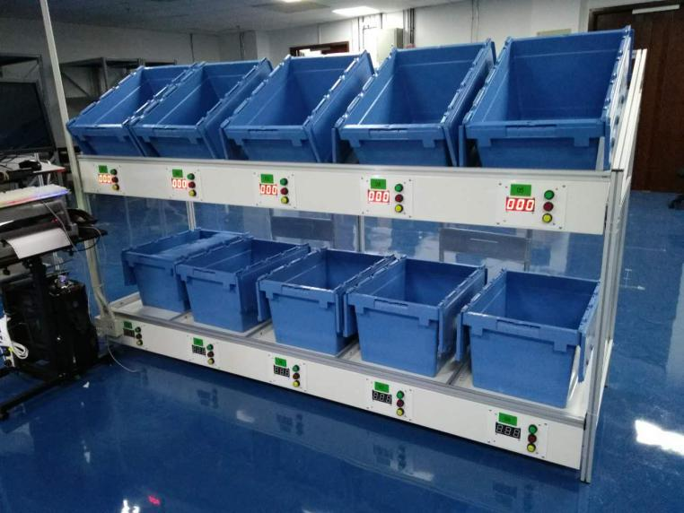
FIG 5: Order-fulfillment containers, mounted on a digital counter rack.

Section 4 – Hardware and Network Configuration

- Uses AP router
- Enterprise-class network (100Mbps, remote monitoring and control, maintenance)
- Runs on blade servers
- Operates on 3 computers at picking stations
- Intranet bandwidth, maximum 1000Mbps
- Uses UPS power supply
- Can use other power supply facilities (depends on facility)
- Has video monitoring system (optional, for customer or Liftians remote monitoring)

Section 5 – Site Layout Planning

- Site requirements: level ground (incline of less than 2 mm/m²), anti-static floor paint
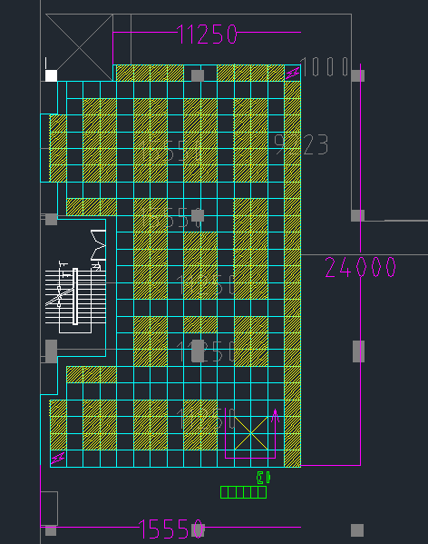
FIG 6: Example site - area of 314 m², 1 digital counter rack, 6 AGV units, 2 charging stations, and 147 standard shelves.

Section 6 – Network topology
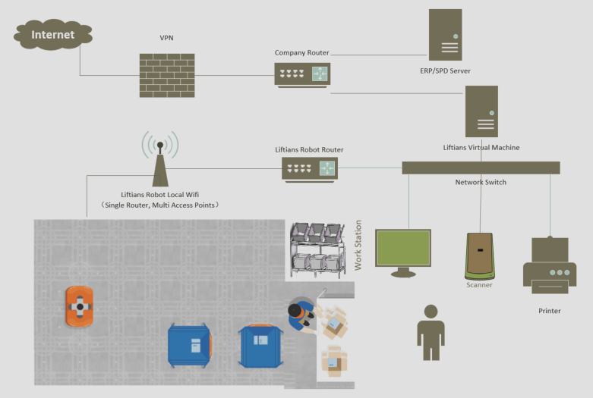
FIG 7: Connectivity and exchanges between client-side and provider-side devices that occur during system operation.

Section 7 – Operation Flowchart
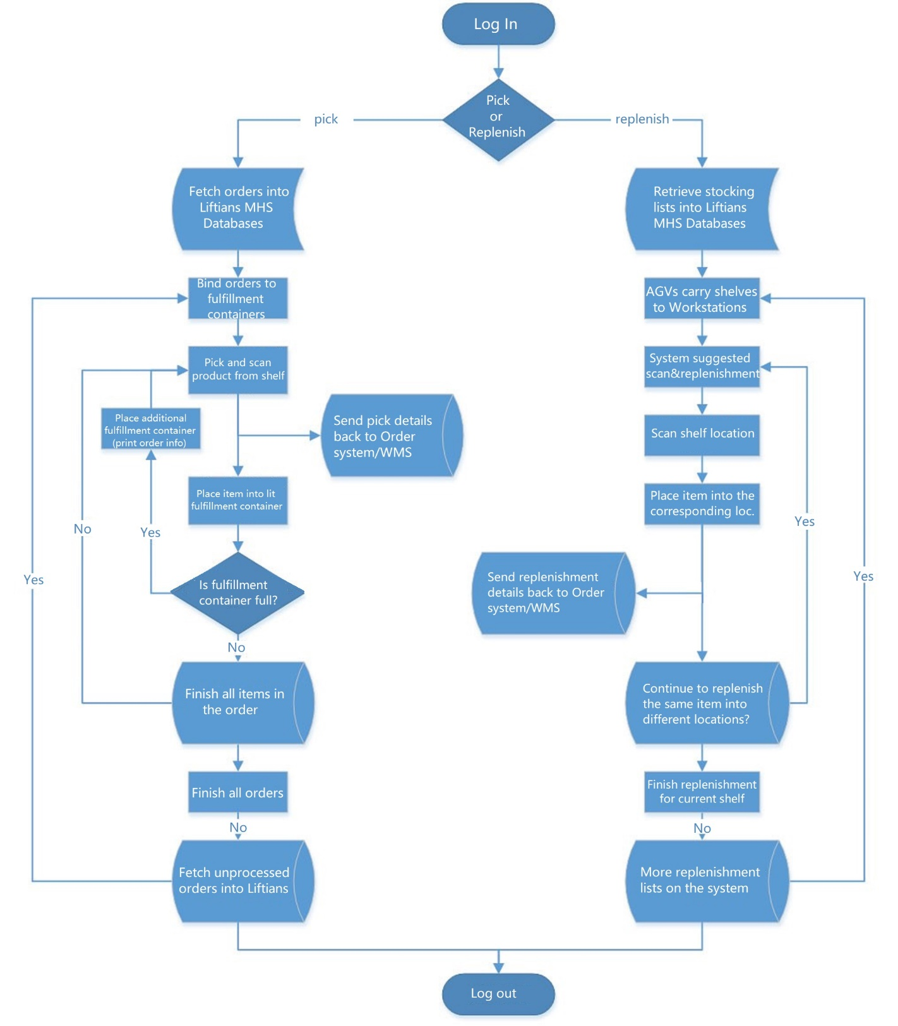FIG 8: A logical schema of dual picking/replenishment functions of MHS- from the operator station, (1) workers can fulfill orders as AGV units deliver customer items, and (2) reload inventory items onto shelves when orders are not currently requested. This double process ensures that the AGV units and workers are fully productive.

Section 8 – Project Implementation Stages
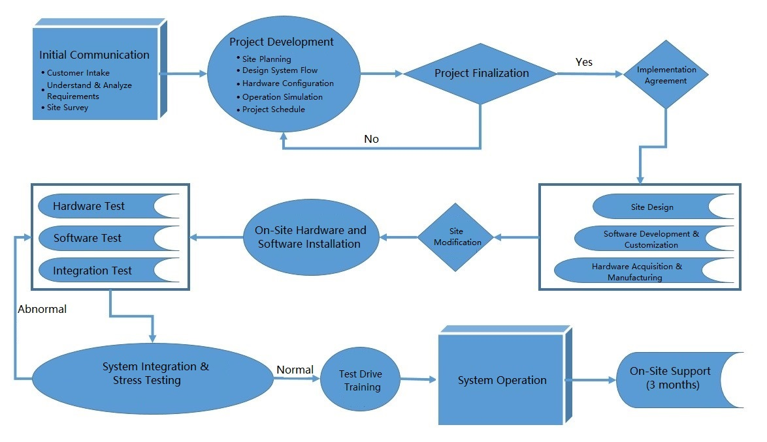
FIG 9: The above is a project implementation flowchart - the entire project cycle is about 6 months. We work closely to understand the client’s needs and then design a project around their facilities. We first simulate the operation of our system before integrating our system. After installation, we assign on-site engineers for 3 months to ensure uninterrupted operation.

Section 9 – Risk Management & Control

Scenario 1: Single/multiple robot(s) malfunction.
Solution: When a unit fails, the system will automatically set a temporary fault zone and path. Other functioning units can bypass the fault zone and path. Workers can manually push aside any malfunctioning units in the zone through the path for repair or replacement.
After removal of malfunctioning units, the system releases the temporary fault zone and path. The MHS will reassign any unfinished tasks to functioning units.

Scenario 2: The whole system completely stops working.
Solution: In the event of a power outage, the system can continue working for 30 minutes due to the uninterruptible power supply (UPS). If electricity remains unavailable after 15 minutes, the system will suspend work and the units will return all the shelves to their original locations.
Workers enter the AGV unit areas. Items will be manually picked and registered with handheld device according to the system backup data (if electricity still available for WiFi and servers).

-END-

