1：Set up server static IP
Connect the eTag device to the server through an ethernet cable, if the server is a Windows computer:
use these steps to assign a static IP configuration using Control Panel:
- Open Control Panel.
- Click on Network and Internet.
- Click on Network and Sharing Center.
- Click the Change adapter settings option on the left navigation pane.
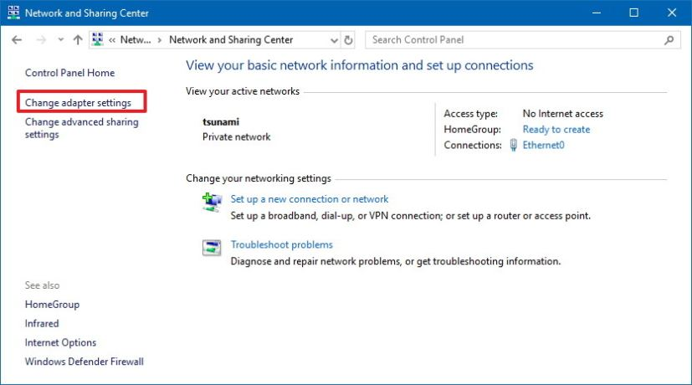Control Panel Network and Sharing Center
- Right-click the network adapter and select the Properties option.
- Select the Internet Protocol Version 4 (TCP/IPv4) option.
- Click the Properties button.
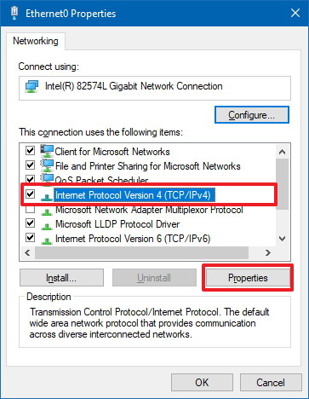Control Panel’s network adapter properties
- Select the Use the following IP address option.
- Assign the static IP address – for example, 192.168.1.111.
- Specify a Subnet mask. Typically, on a home network, the subnet mask is 255.255.255.0.
- Specify a Default gateway. (Usually, your router’s IP address – for example, 192.168.1.1.)
- Under the “Use the following DNS server addresses set Preferred DNS server” section, set the Preferred DNS server address, which is usually your router’s IP address or server IP address providing DNS resolutions (for example, 192.168.1.1).
- (Optional) Specify an Alternative DNS server, which the computer will use if it cannot reach the preferred DNS server.
- Click the OK button.
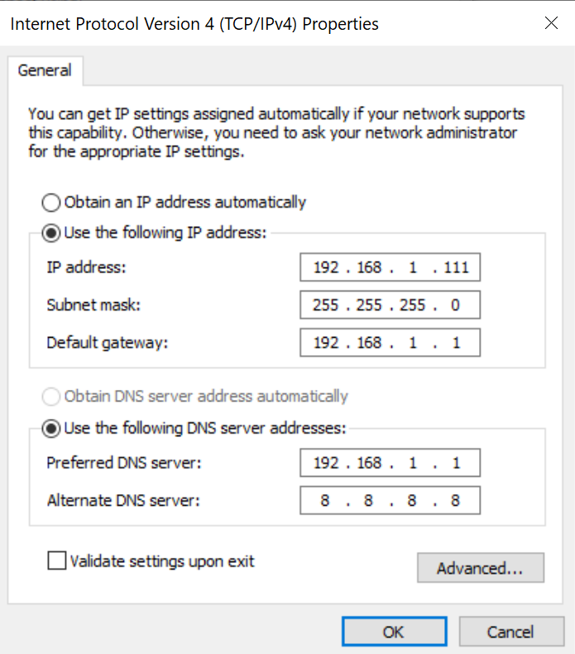
Windows 10 network adapter TCP/IPv4 properties
- Click the Close button again.
Now, the server is set up with a static IP address (192.168.1.111)
Use netsh in command prompt to confirm the ip information
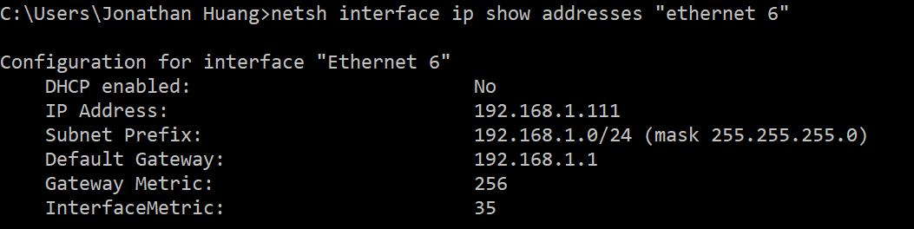

2：Configuration of eTag device
Run CnetCfg application
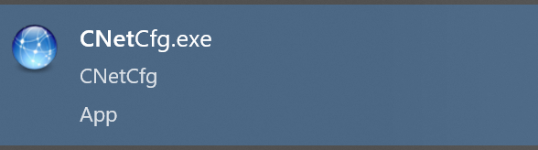
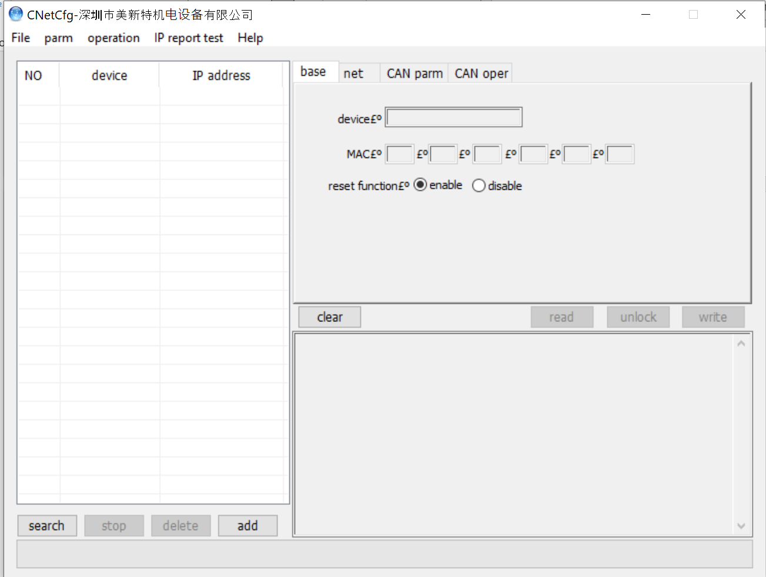
Click on the net tab and select Static in the IP method drop down list
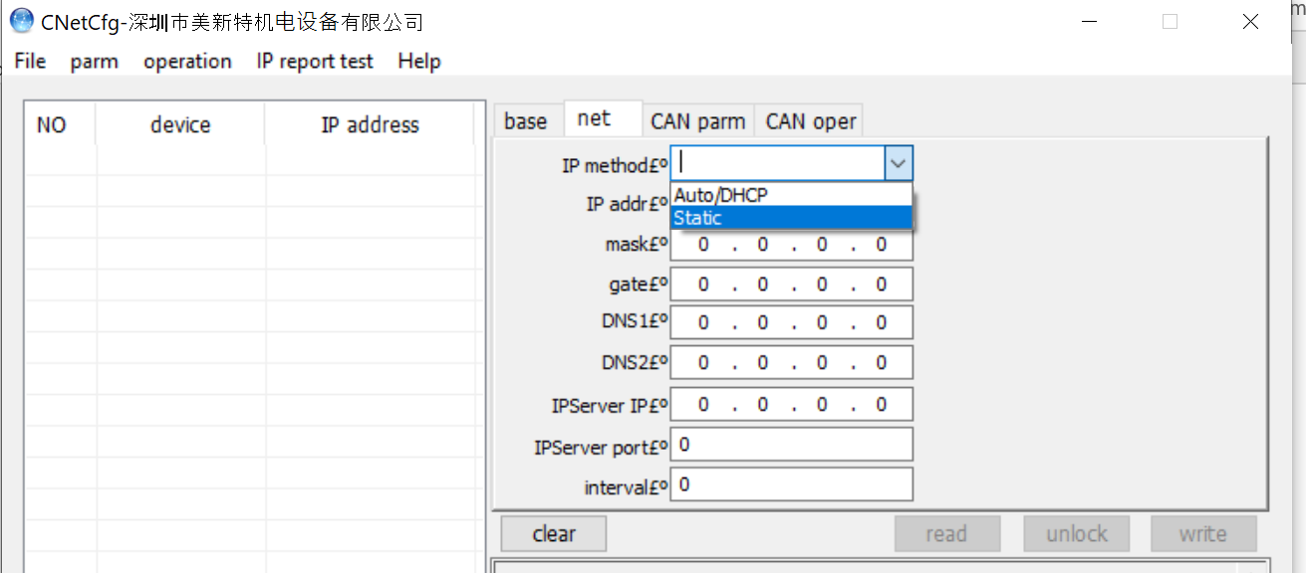
Click on add to select the device type (CNET 100) and assign an IP address
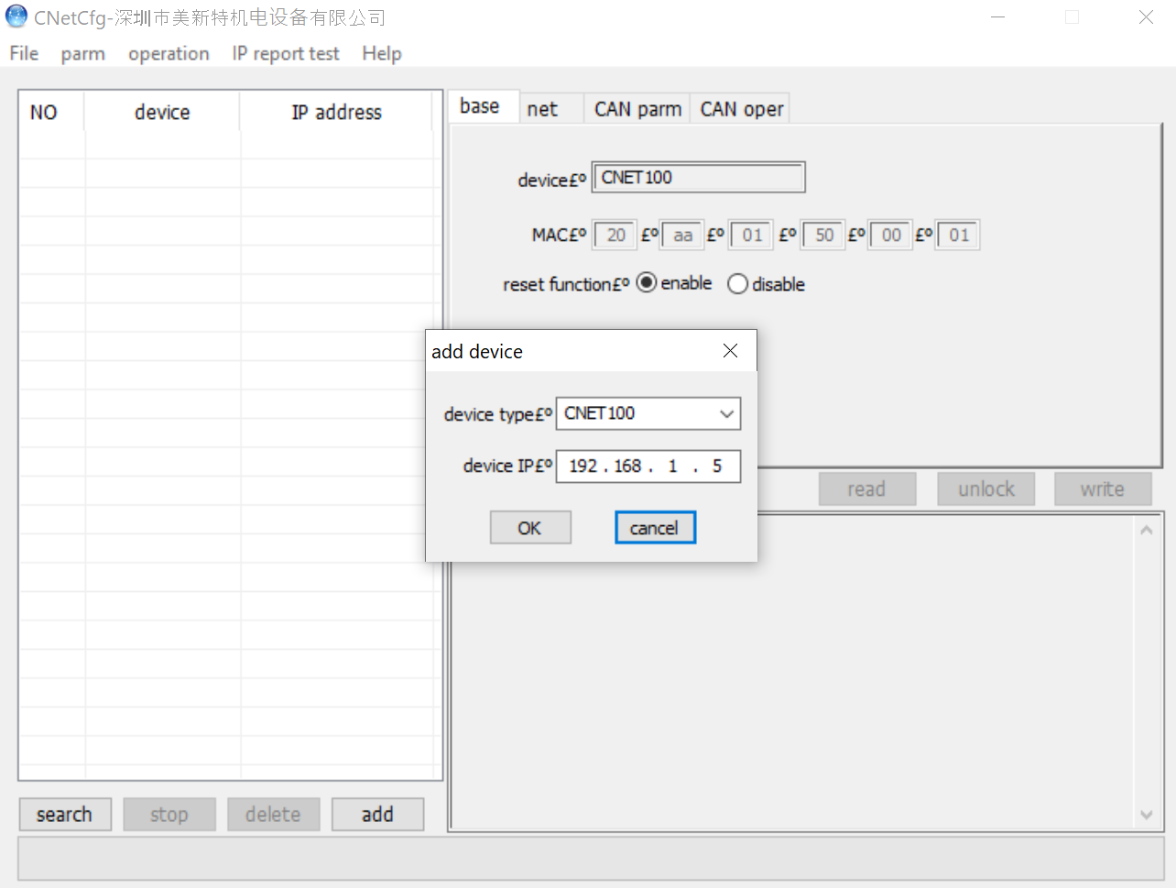
Go to the net tab to read the device IP information
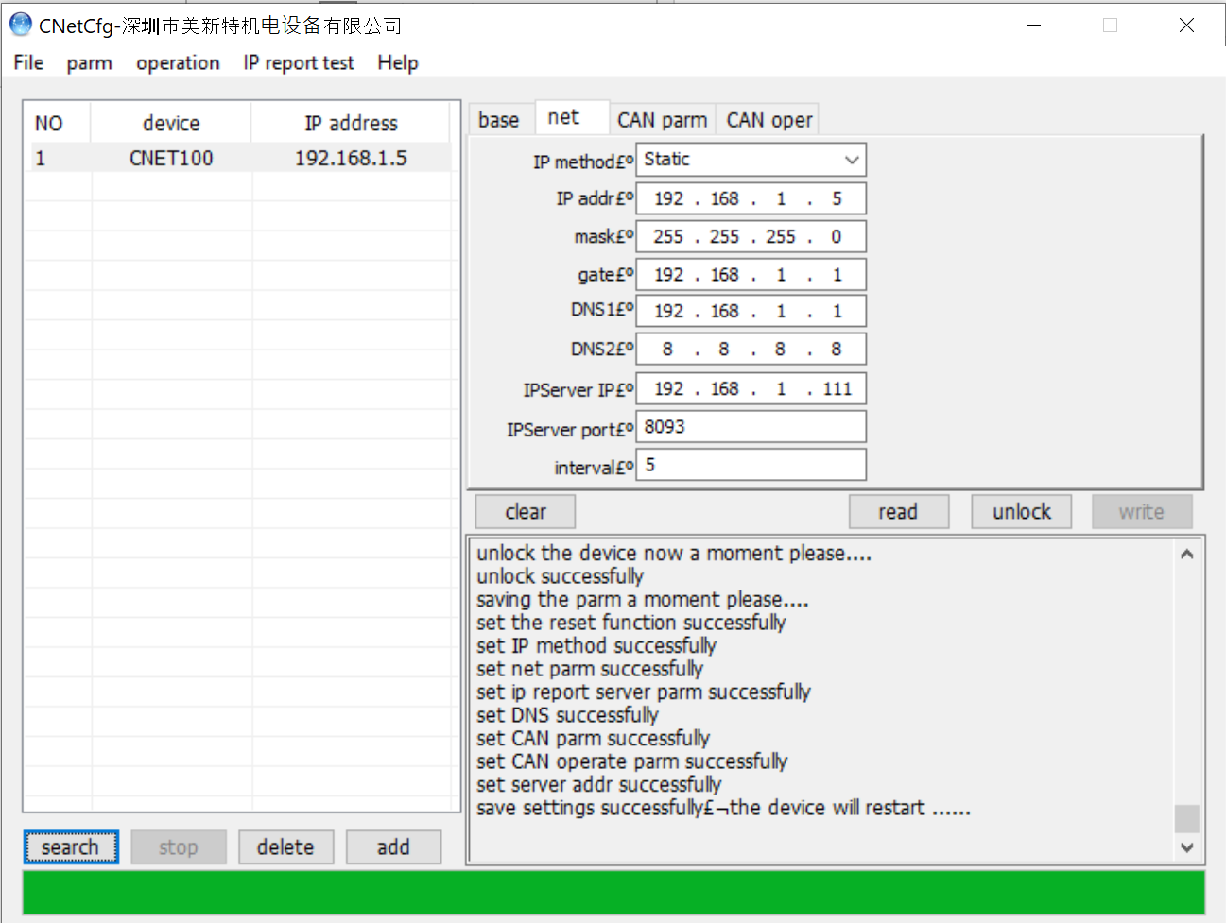
The IP information can be overwritten by clicking on unlock first, fill in the new data, and click on the write button. You can check the information by clicking on read button.
Use CAN Operation tab to set the protocol to TcpClient, verify the IP address and Port number
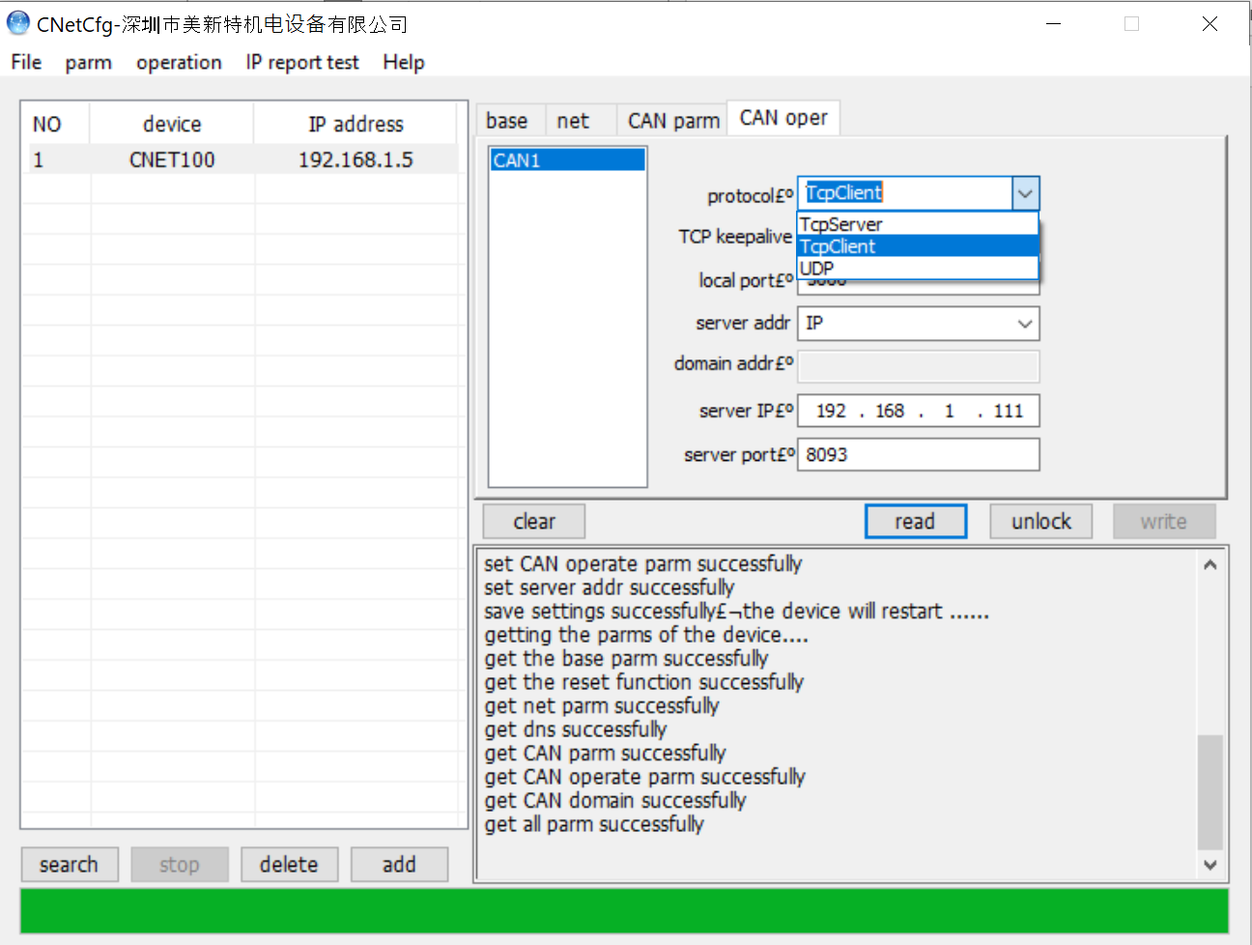
NOTE: the server port is 8093

3：Installation of Liftians eTag application
Run Java program apiServiceGateway.jar
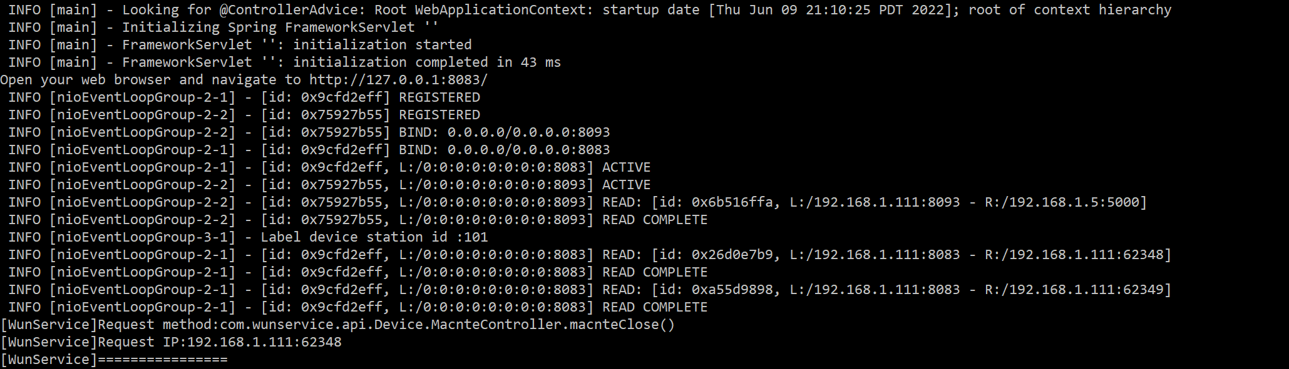

4：Set up database information
The java application is connected to MySQL Server where the device connection information is stored.
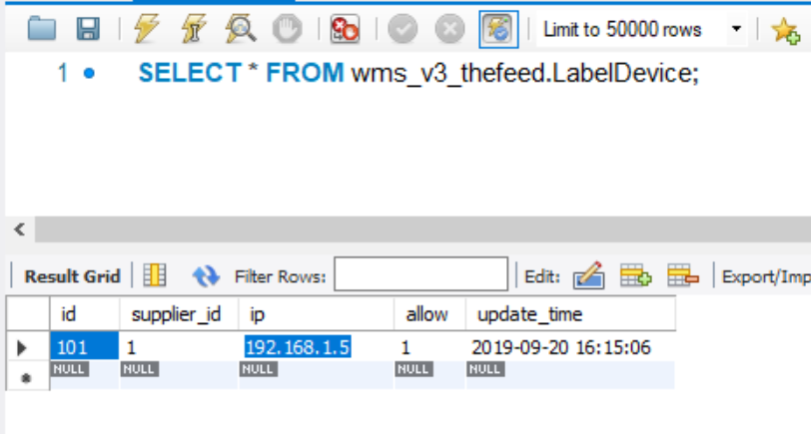

5: Running the API via URL
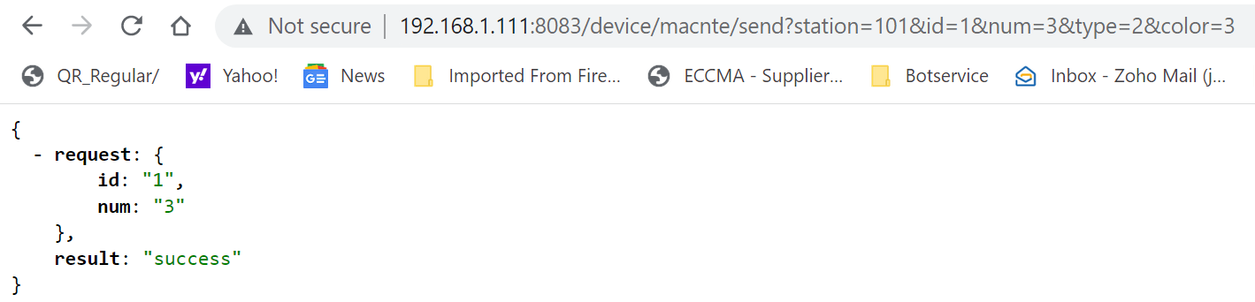
NOTE: The URL port is 8083, which is reserved for the Liftians eTag application

