New Robot Configuration

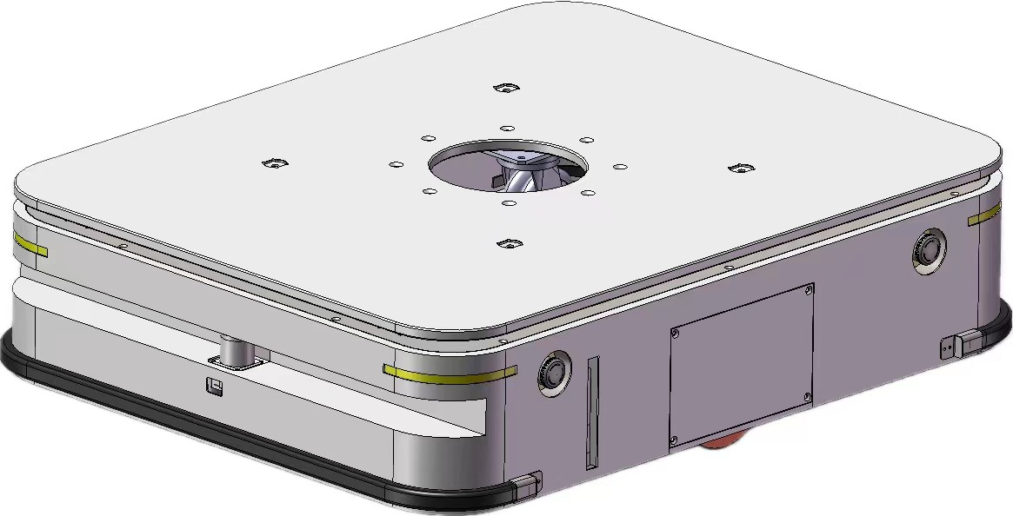

Model | CQR-1500 | SN | CQR152401080057
Engineer | Allen Cheung | Date | Jan 8 2024

Network Topology

Local LAN | SSID | Laser_Cart
Local LAN | PW | okagv2015
Local LAN | IP | 192.168.1.1
CQR-1500 | MOXA-1137C | WLAN | 192.168.1.157
CQR-1500 | MOXA-1137C | WLAN | ID:admin
CQR-1500 | MOXA-1137C | WLAN | PW:moxa
CQR-1500 | MOXA-1137C | LAN | 192.168.0.1
CQR-1500 | RASP-PI | WLAN | 192.168.1.57
CQR-1500 | RASP-PI | ETH0 | 192.168.0.3
CQR-1500 | RASP-PI | ETH1 | 192.168.126.252
CQR-1500 | LRC-600 | ETH | 192.168.0.2
CQR-1500 | LRC-600 | Remote server | 192.168.1.2/9007
CQR-1500 | LRC-600 | Remote server | 192.168.1.251/51888
CQR-1500 | LRC-600 | Remote server | 192.168.1.252/51888
CQR-1500 | LRC-600 | Remote server | 192.168.0.3/51888
CQR-1500 | LRC-600 | Remote server | 192.168.126.253/51888(wired)

Network settings on the computer (Already configured on the Y4B computer)
There are two network settings on the computer:
To get to the Internet Protocol Version 4 (TCP/IPv4) Properties, follow the steps below:
Control Panel > Network and Internet > Network and Sharing Center > Connections > Properties > Internet Protocol Version 4 (TCP/IPv4) > Properties
- Wifi to Laser_Cart:
  - Static IP:
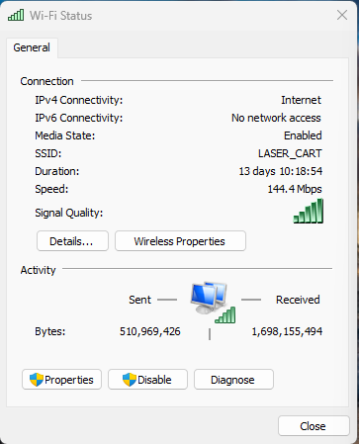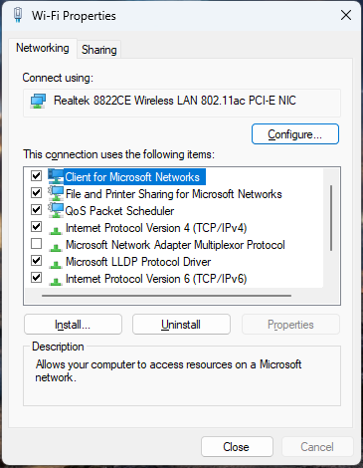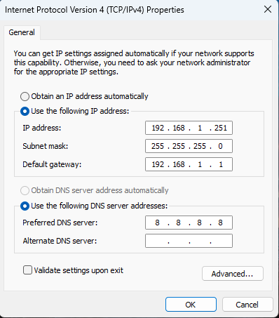

- Ethernet Cable directly connected to the robot:
  - Static IP: 192.168.126.253

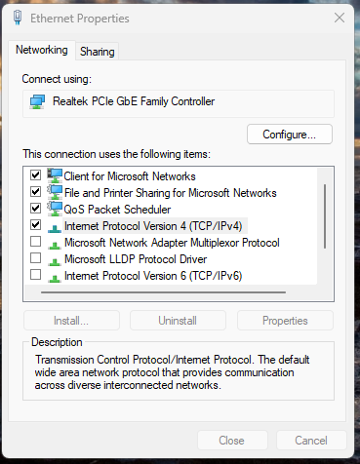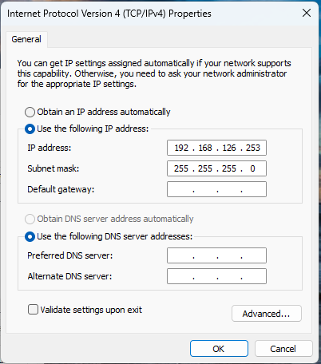

Run VNC Viewer
While the ethernet cable is being connected, run the VNC Viewer program.
- Connecting to the Raspberry Pie IP 192.168.126.252 with ID: liftians and password being the same as of MM. The 192.168.126.252 IP is the static IP within the Raspberry Pie environment
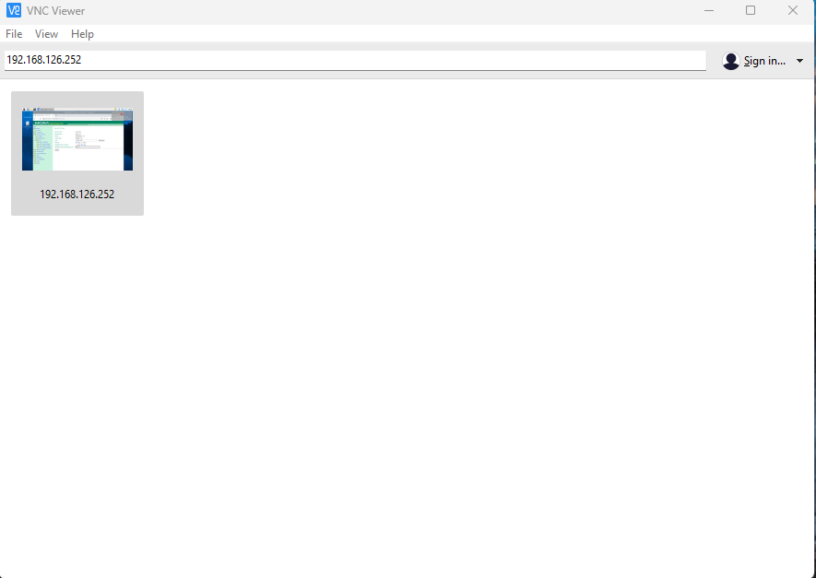
- Inside the VNC Viewer, open the web browser to access 192.168.0.1 Moxa page to change the password and other network settings
- Save and restart the Moxa program to make the changes effective. It will take about one minute to restart the Moxa router

Log in to Moxa page outside VNC Viewer
- Open the web browser with IP: 192.168.1.1XX, XX is the robot number. Click on Import/Export on the home page.
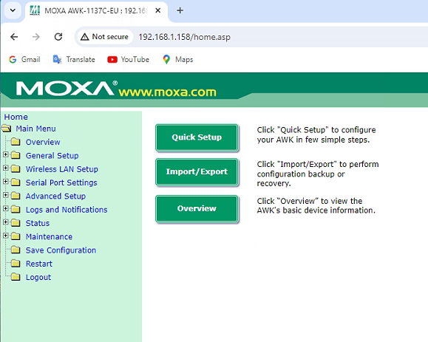

- Import the network configuration file from bot 51.
Choose File (Desktop > NewRobotSetup > Config_51 ) > Open > Import Configuration
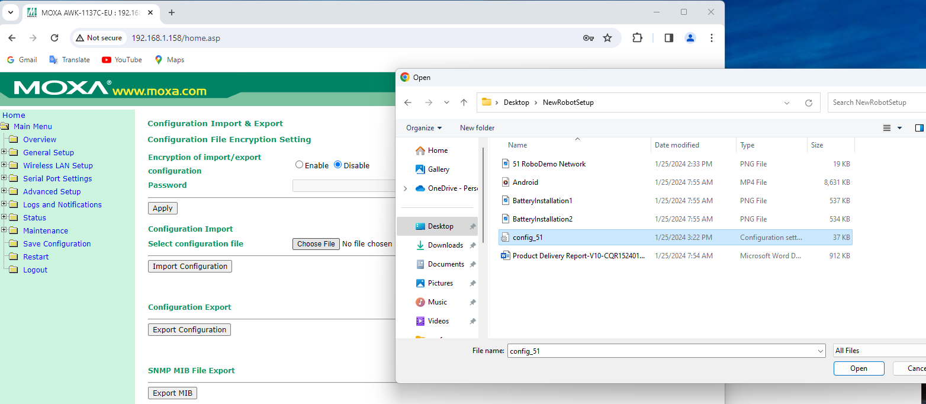
- Change the IP address to 192.168.1.1XX from 192.168.1.151

- General Setup > Network Settings
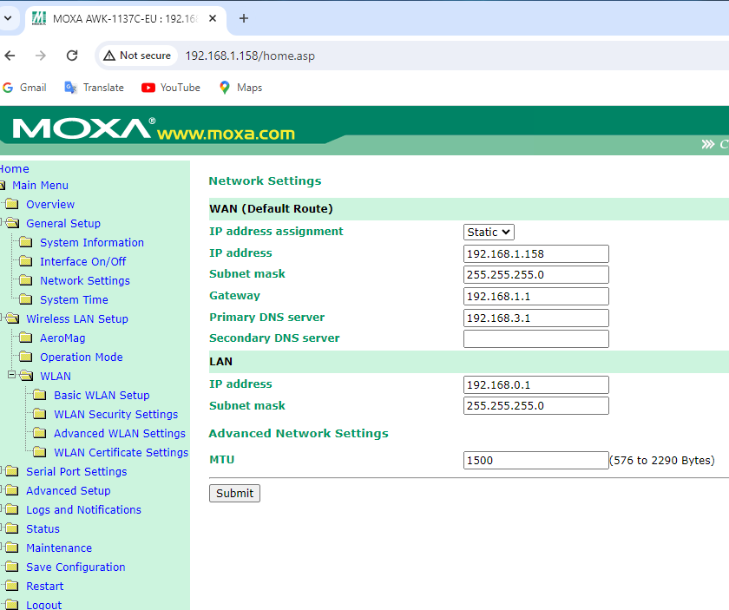

- Save Configuration and Restart
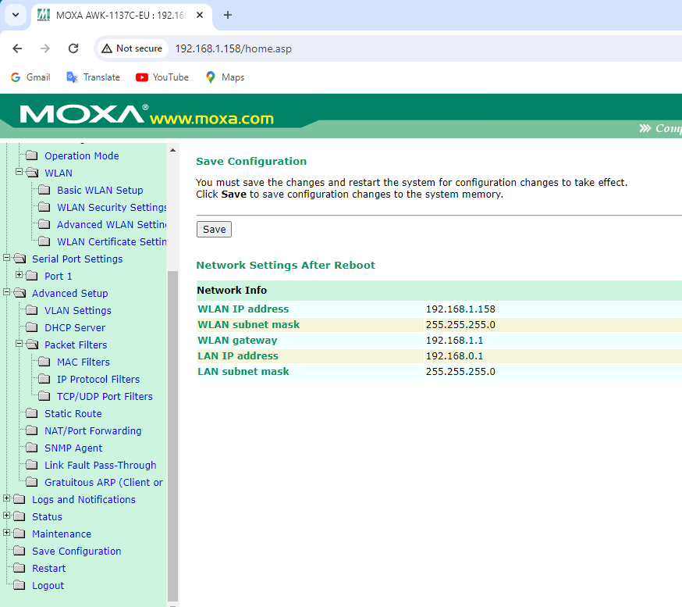

Configuration
Use the network configuration for Bot 51 as HWF network connections (Primary and Secondary Servers)
RoboDemo connection > RoboCheck > Protocal Switch to LiftiansTest > RoboConfig to select an IP > Read from Network Param> Modify Network parameters and Write
Network Config (HWF) | Robo. Model Config.
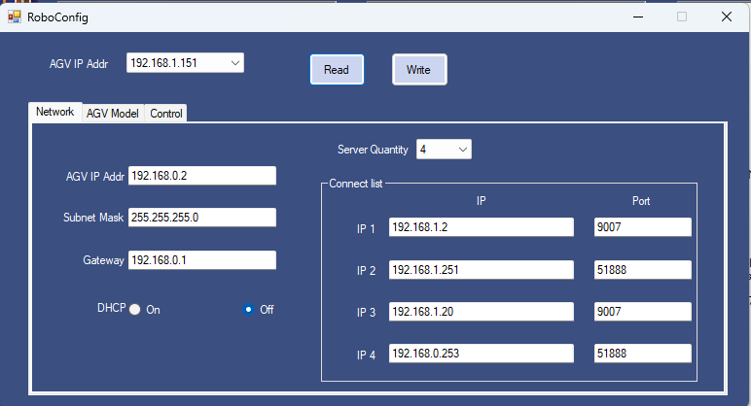 | 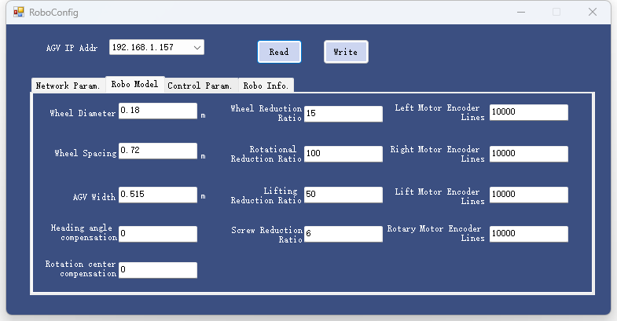
Robo. Control Config. | Robo. Info.
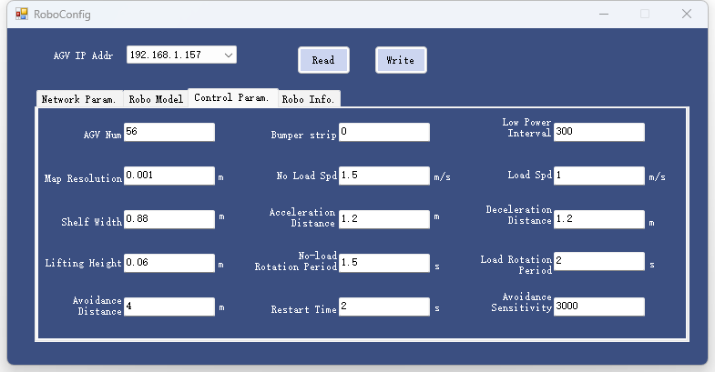 | 