Product Delivery Report

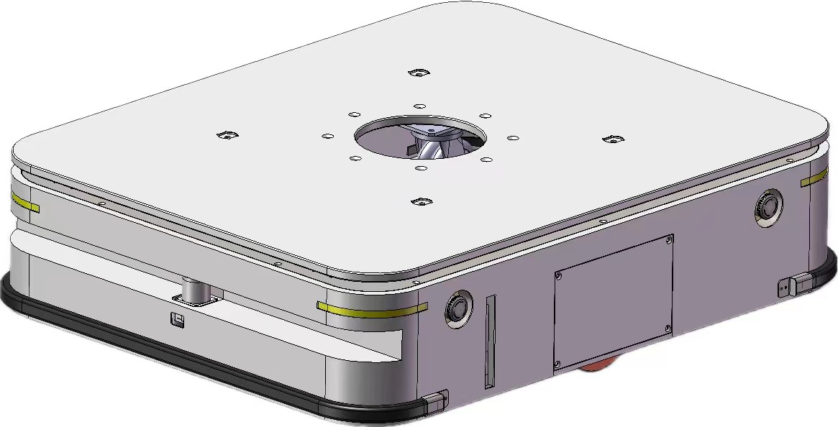

Model | CQR-1500 | SN | CQR152401080057
Engineer | Allen Cheung | Date | Jan 8 2024

Network Topology
Local LAN | SSID | Laser_Cart
Local LAN | PW | okagv_2015
Local LAN | IP | 192.168.1.1
CQR-1500 | MOXA-1137C | WLAN | 192.168.1.157
CQR-1500 | MOXA-1137C | WLAN | ID:admin
CQR-1500 | MOXA-1137C | WLAN | PW:moxa
CQR-1500 | MOXA-1137C | LAN | 192.168.0.1
CQR-1500 | RASP-PI | WLAN | 192.168.1.57
CQR-1500 | RASP-PI | ETH0 | 192.168.0.3
CQR-1500 | RASP-PI | ETH1 | 192.168.126.252
CQR-1500 | LRC-600 | ETH | 192.168.0.2
CQR-1500 | LRC-600 | Remote server | 192.168.1.2/9007
CQR-1500 | LRC-600 | Remote server | 192.168.1.251/51888
CQR-1500 | LRC-600 | Remote server | 192.168.1.252/51888
CQR-1500 | LRC-600 | Remote server | 192.168.0.3/51888
CQR-1500 | LRC-600 | Remote server | 192.168.126.253/51888(wired)

Configuration
Network Config. | Robo. Model Config.
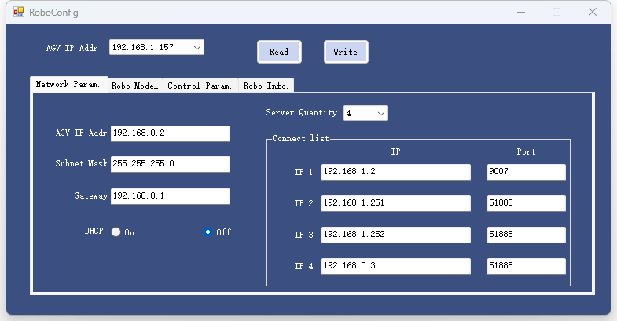 | 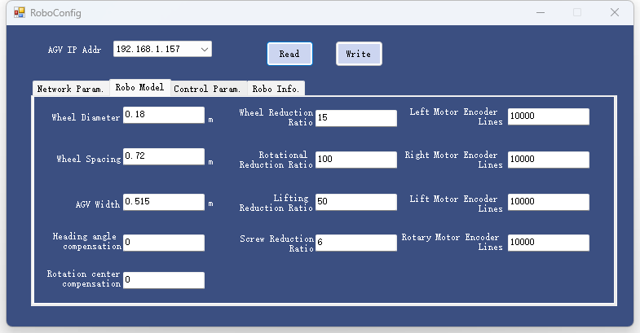
Robo. Control Config. | Robo. Info.
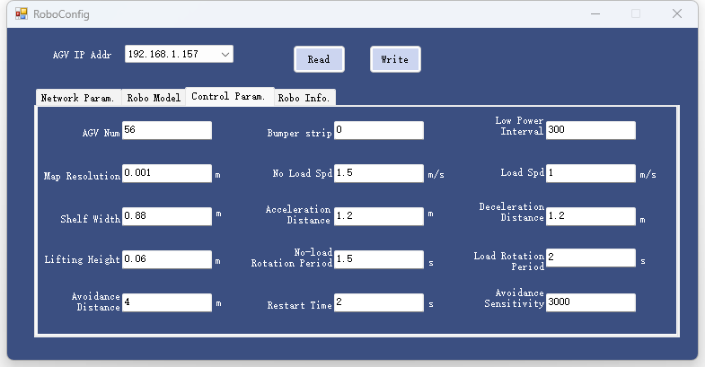 | 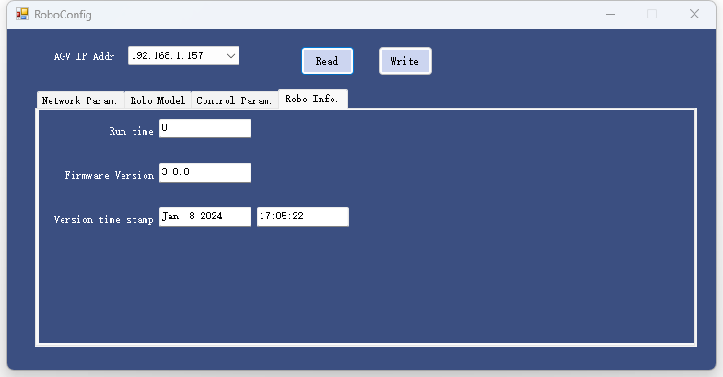

Check list

